****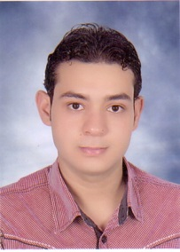

**Abdel hakim hashmat abdel hakim**

[**Abdel hakim28@yahoo.com**](mailto:%20Abdel%20hakim28@yahoo.com)

**Education**



**PERSONAL DATA**

* **Date of Birth: 23/2/1992**
* **Gender : male**
* **Marital status: Single**
* **Nationality: Egyptian**
* **Graduated from the Faculty of art, Assiut University, 2013**

**LANGUAES**



* **To obtain a good position that allows me to embody my ideas to reality with a major Corporation that lead to higher learning and skills improvement**
* **Improve the scientific and educational level of students and increase social awareness towards the issues and problems of society**
* **In addition to I am looking forward to enjoy working through a team work environment with like-mined thinkers.**

**OBJECTIVE**





* **Ability to work individually and as a co-operative team member**
* **Responsibility and Honesty.**
* **Able to work in a team .**
* **Good communication skills with the students**
* **Good knowledge of Microsoft Office (Word, Excel, PowerPoint, Access, Internet) and Data entry**

**PROFESSIONAL SKILLS**



* **Microsoft Office Good**
* **Arabic: Mother language**
* **English: Good**

**Computer SKILLS**